**June 5 2020**

**Cognitiveclass: PY0101EN Python for Data Science**

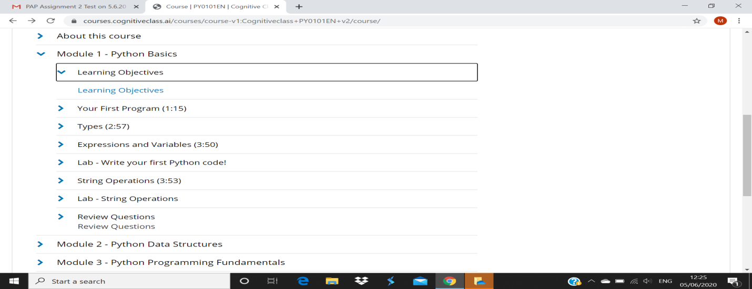

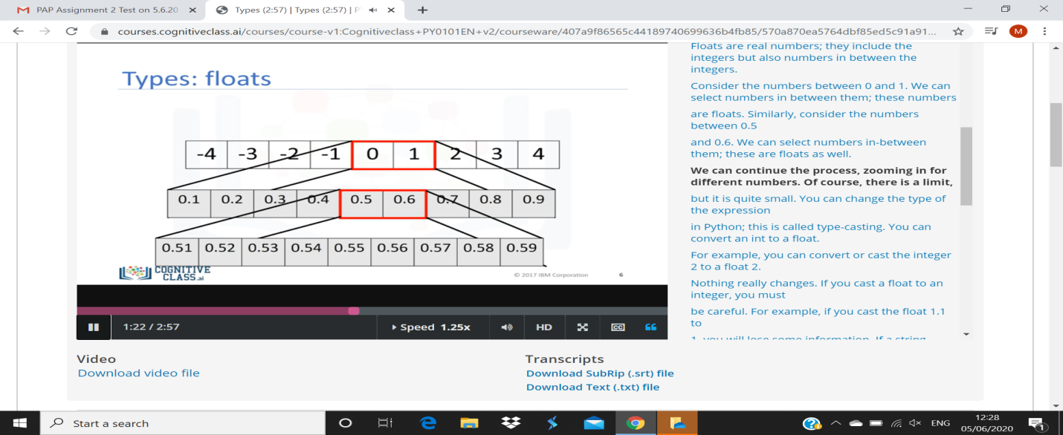

Consider the numbers between 0 and 1. We can select numbers in between them; these numbers

are floats. Similarly, consider the numbers between 0.5

and 0.6. We can select numbers in-between them; these are floats as well.

**We can continue the process, zooming in for different numbers. Of course, there is a limit,**

but it is quite small. You can change the type of the expression

1. in Python; this is called type-casting. You can convert an int to a float.
2. For example, you can convert or cast the integer 2 to a float 2.